**A CRISPRi-Seq screen for functional assessment of BRCA1 mutants**

**Introduction**

For the proper functioning and stability of the genome, the BRCA1 gene is very essential which helps in DNA repair, and mutations in this gene raise the risk of breast and ovarian cancer[[1]](https://paperpile.com/c/pQ4QIb/V7s5). There are limitations to the variant pathogenicity essays currently in use. Targeted genome editing is possible with CRISPR-Cas9, yet it is ineffective for large genes like BRCA1[[2]](https://paperpile.com/c/pQ4QIb/ufCn). Precise nucleotide substitutions are made possible by Base Editor 3(BE3), which facilitates functional assessment and helps detect the pathogenicity of unknown BRCA1 variants[[3]](https://paperpile.com/c/pQ4QIb/2zbV).

**Aim**

This study aims to utilise CRISPR-mediated base editing with BE3 for the functional analysis of BRCA1 variants, identifying novel variants and reclassifying variants of uncertain significance.

**Pipeline**

**Results**

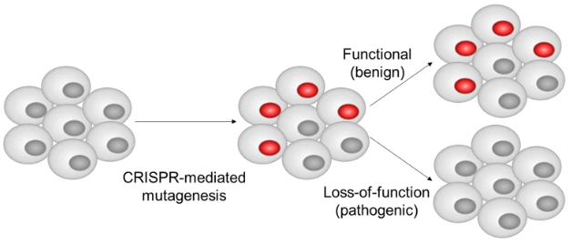 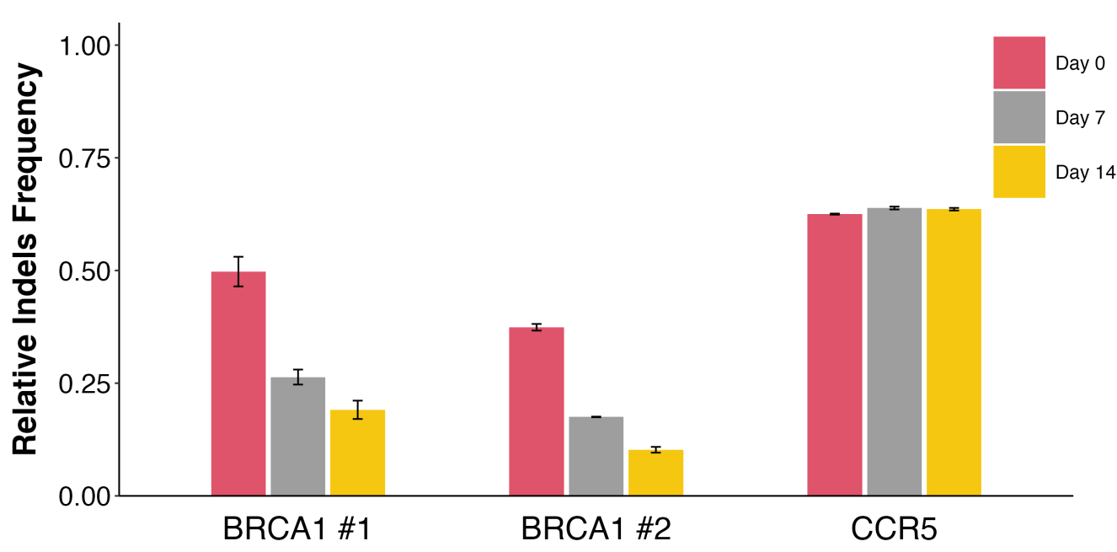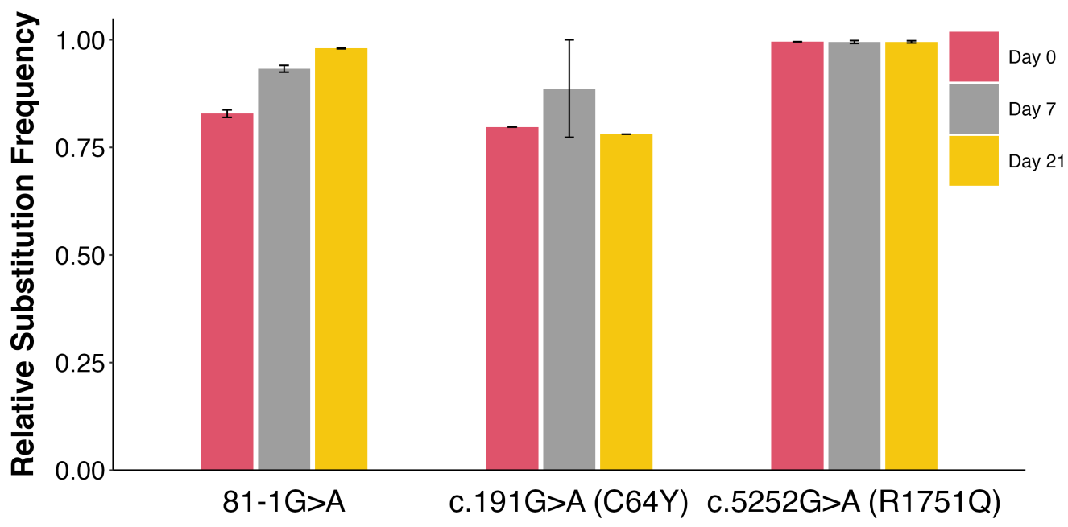

1. **(b)** **(c)**

**Fig 1: (a)** Schematic overview of the functional analysis of BRCA1 via targeted mutagenesis **(b)** Cell viability analysis of HAP1-Cas9 cells transfected with two different gRNAs targeting BRCA1 using targeted deep sequencing. BRCA1 #1 and BRCA1 #2 indicate each BRCA1-targeting gRNA, and the CCR5-targeting gRNA was used as a negative control **(c)** Cell viability analysis of HAP1-BE3 cells transfected with gRNAs targeting pathogenic mutations [c.81-1G>A and c.191G>A (p.C64Y)] and a benign mutation [c.5252G>A (p.R1751Q)] using targeted deep sequencing

**Discussion**

HAP1-Cas9 cells were used to disrupt BRCA1 with gRNAs, showing decreasing indel frequencies over time with olaparib treatment. HAP1-BE3 cells introduced pathogenic BRCA1 mutations (c.81-1G>A, c.191G>A) with reduced substitution frequencies, contrasting with a likely benign variant (c.5252G>A) retaining its frequency.

**Significance**

1. CRISPR-mediated base editing can aid in the functional analysis of BRCA1 variants, helping to identify novel variants and reclassify variants of uncertain significance.

2. The study findings can contribute to improving the accuracy of clinical genetic testing for BRCA1 mutations, enhancing the management of individuals at risk of breast and ovarian cancers.

3. Utilizing CRISPR technology for functional assessment provides a powerful tool for evaluating the pathogenicity of BRCA1 variants, potentially guiding personalised treatment strategies for patients with identified mutations.

**References**

1. [Roy R, Chun J, Powell SN. BRCA1 and BRCA2: different roles in a common pathway of genome protection. Nat Rev Cancer. 2011;12: 68–78.](http://paperpile.com/b/pQ4QIb/V7s5)

2. [Knott GJ, Doudna JA. CRISPR-Cas guides the future of genetic engineering. Science. 2018;361: 866–869.](http://paperpile.com/b/pQ4QIb/ufCn)

3. [Kweon J, Jang A-H, Shin HR, See J-E, Lee W, Lee JW, et al. A CRISPR-based base-editing screen for the functional assessment of BRCA1 variants. Oncogene. 2020;39: 30–35.](http://paperpile.com/b/pQ4QIb/2zbV)